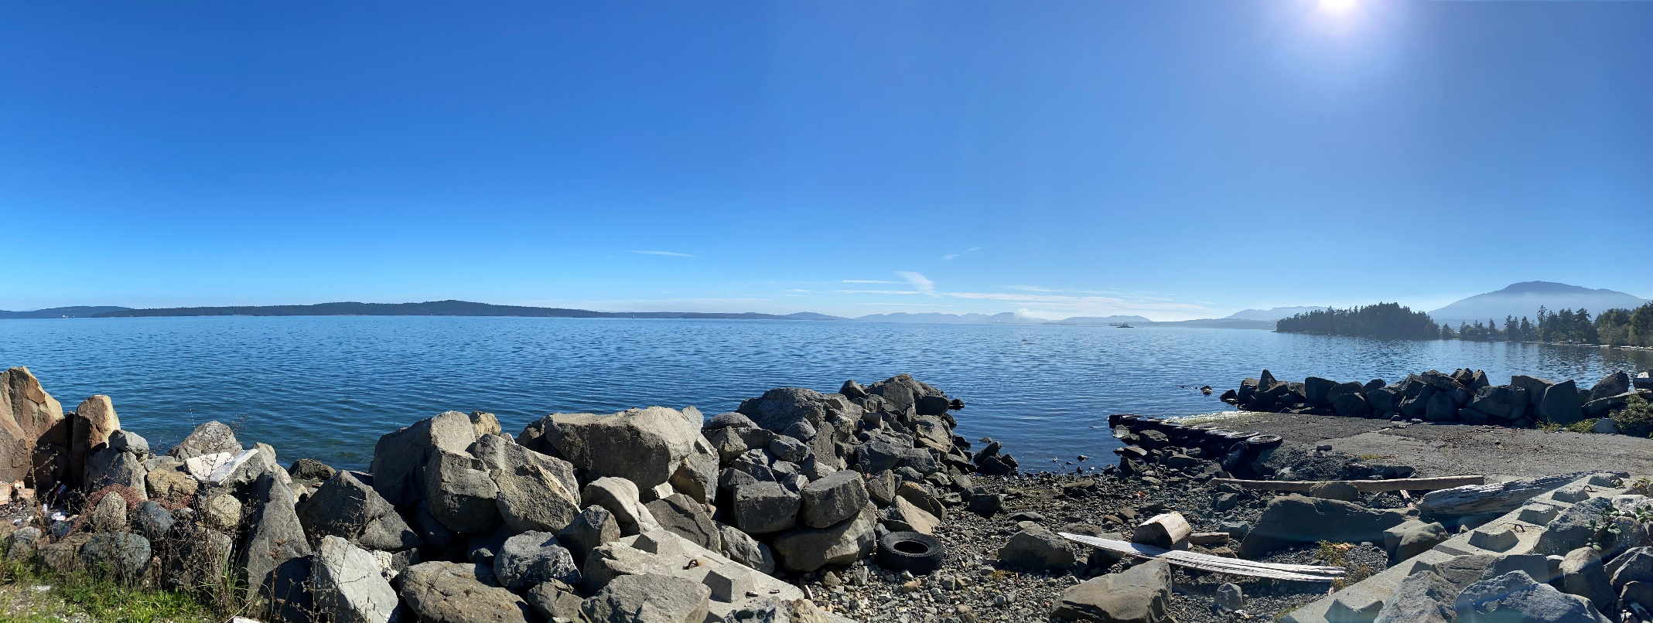

First Nation

Infrastructure Maintenance Management Plan

Water and Wastewater Assets

LOGO

Month Day, Year | DRAFT

Contents
1. Introduction 1
2. Water and Wastewater Asset Summary 2
3. Available Engineered Drawings and Component Maintenance Manuals 3
4. Health and Safety Policies 5
5. Relevant Regulations, Policies, and Permits 6
6. Preventative Maintenance Schedule 7
7. Preventative Maintenance Budget 8
8. Work Orders 9
9. Reporting 11

Appendices
Appendix A: Annual Maintenance Schedule
Appendix B: Annual Maintenance Budget
Appendix C: Work Orders
Appendix D: Reporting

- Introduction
The following Maintenance Management Plan has been prepared for Sample First Nation in support of water and wastewater infrastructure assets on Lands.
The purpose of this document is to outline Maintenance plans, costs, and labour, equipment and material required to perform preventative and major maintenance tasks for Lands water and wastewater linear infrastructure.
In conjunction with this manual, operating manuals of the installed equipment must always be consulted prior to start-up and shut-down, as well as for routine operation, maintenance, inspection, and repair.
The operation and maintenance specifications contained in this document are provided for reference only and DO NOT provide a complete overview of safe operating conditions and requirements. It is the responsibility of each Operator to comply with all applicable regulations such as Workplace Hazardous Materials Information System (WHMIS) and Occupational Health and Safety Regulations.
The information contained in this manual is specific to the specified infrastructure on Lands.

- Water and Wastewater Asset Summary
Sample First Nation water and wastewater infrastructure assets on Lands consist of the following:
SANITARY SYSTEM COMPONENT | QUANTITY

WATER SYSTEM COMPONENT | QUANTITY

The locations of these components are indicated on the GIS Vertisee site, accessible via the following link: xxx
  - List of Qualified Contractors
SERVICE | COMPANY | CONTACT

- Available As-Constructed Drawings and Component Maintenance Manuals
Table 1 - Available Drawings - Water and Wastewater
DRAWING SET NAME | ENGINEER/DESIGNER | DATE

Table 2 - Maintenance Manuals - Water and Wastewater
MAINTENANCE MANUAL TITLE | ENGINEER/DESIGNER | DATE

Digital copies of the above noted documents can be found in XX.

- Health and Safety Policies
Table 3 - Health and Safety Policies
REVIEW POLICIES AND ADD/REMOVE AS REQUIRED
ASSET | HEALTH AND SAFETY POLICY | REFERENCE DOCUMENT
WATER | OHS Guidelines Part 4: General Conditions  - Working Alone or In Isolation  - Ergonomics (MSI) Requirements | https://www.worksafebc.com/en/law-policy/occupational-health-safety/searchable-ohs-regulation/ohs-guidelines/guidelines-part-04
WATER | OHS Guidelines Part 8: Personal Protective Clothing and Equipment | https://www.worksafebc.com/en/law-policy/occupational-health-safety/searchable-ohs-regulation/ohs-guidelines/guidelines-part-08
WATER | OHS Guidelines Part 18: Traffic Control | https://www.worksafebc.com/en/law-policy/occupational-health-safety/searchable-ohs-regulation/ohs-guidelines/guidelines-part-18
SANITARY | OHS Guidelines Part 4: General Conditions  - Working Alone or In Isolation  - Ergonomics (MSI) Requirements  - Illumination | https://www.worksafebc.com/en/law-policy/occupational-health-safety/searchable-ohs-regulation/ohs-guidelines/guidelines-part-04
SANITARY | OHS Guidelines Part 8: Personal Protective Clothing and Equipment | https://www.worksafebc.com/en/law-policy/occupational-health-safety/searchable-ohs-regulation/ohs-guidelines/guidelines-part-08
SANITARY | OHS Guidelines Part 9: Confined Spaces | https://www.worksafebc.com/en/law-policy/occupational-health-safety/searchable-ohs-regulation/ohs-guidelines/guidelines-part-09
SANITARY | OHS Guidelines Part 18: Traffic Control | https://www.worksafebc.com/en/law-policy/occupational-health-safety/searchable-ohs-regulation/ohs-guidelines/guidelines-part-18

- Relevant Regulations, Policies, and Permits
Table 4 - Policies and Regulations
REVIEW POLICIES AND ADD/REMOVE AS REQUIRED
ASSET | POLICY / REGULATION | GOVERNING BODY | REFERENCE DOCUMENT
WATER | Water Sustainability Act | Provincial | https://www.bclaws.gov.bc.ca/civix/document/id/complete/statreg/14015
WATER | Guidelines for Canadian Drinking Water Quality | Federal | https://www.canada.ca/en/health-canada/services/environmental-workplace-health/reports-publications/water-quality/guidelines-canadian-drinking-water-quality-summary-table.html

Table 5 – Permits
ASSET | PERMIT | GOVERNING BODY | REFERENCE DOCUMENT

- Preventative Maintenance Schedule
An Annual Maintenance Schedule is provided in Appendix A. The Annual Maintenance Schedule contains a list of all inspection and prevention maintenance tasks including:
- Activities with work orders numbered and grouped to indicate the work required for individual people or contractors;
- Person-hours for each activity shown weekly with a summary of total hours for the year.

- Preventative Maintenance Budget
An Annual Budget is provided in Appendix B. The budget shows the Operation and Maintenance costs including:
- An estimate of the annual cost of routine preventative maintenance;
- An estimate of the annual minor preventative repair costs;
- An estimate of operating costs including fuel.

- Work Orders
Work Orders for the Lands Infrastructure are provided in Appendix C.
Each Work Order describes:
- Step by step, simple instructions of the routine and special maintenance duties;
- The safe number of persons required, and the equipment, tools and materials needed;
- The frequency or level of service;
- Estimated number of person-hours involved in each task;
- Contracted services if required.
  - Work Order Index
The following table lists all suggested work orders applicable to the water and wastewater infrastructure located on the Lands.
Table 6 - Table of Work Orders
ASSET | WORK ORDER | DESCRIPTION | FREQUENCY

  - Recommended Maintenance Equipment
A list of recommended tools/equipment and materials/supplies to conduct maintenance work outlined in the suggested work orders is provided below.
REVIEW EQUIPMENT AND ADD/REMOVE AS REQUIRED
SUGGESTED EQUIPMENT LIST
PPE (safety boots, glasses, gloves) | Hydrant Wrench | Compactor
Maintenance Truck | Hydrant Pump | Tamper
Traffic Cones | Valve Key | Mud Pump
Safety Harness | Valve Pick | Misc. Hand Tools
Spotlight | Meter Box Key | Compressor and blowpipe
Mirrors | 2.5” Valve | Shovels
Jet Cleaning Ball | Power Rodder | Wheelbarrow
Poly Rope | Inspection Log | Grease Gun
Manhole Jack | Control Panel Keys | Squeegee
Manhole Lifter | Wrench Set | Chlorine Test Kit
Hand Pump | Multimeter | Bobcat
Fire Hose | Backhoe

SUGGESTED MATERIALS AND SUPPLIES LIST
Epoxy Paint (yellow, red) | Oil | Repair clamps
Paint brushes, rags | Lubricant | Spare parts (valves, o-rings, etc.)
Number stencils | Sand | Chlorine tablets
Cement/Grout | Gravel | Sodium thiosulphate
Fuel | Flow recording Strip | Pipe/repair sleeves/couplings, etc.
Coolant

A list of task specific materials, supplies, and equipment can be found on individual work orders.

- Reporting
Templates for Reporting are found in Appendix D. The reporting templates include layout for input such as:
- Routine inspection and special maintenance duties;
- Operation and Maintenance and monitoring data log;
- Operator’s name, training and certification information;
- Proposed O&M cost estimate for each task related to routine inspection/maintenance including:
  - Wages,
  - Service contractors,
  - Utility bills,
  - Repair/Replacement Costs.

Appendix A

Annual Maintenance Schedule

Appendix B

Annual Maintenance Budget

Appendix C

Work Orders

Appendix D

Reporting

